Analyzing Credit Card Customer Data
Data Science Senior Capstone
Bonnie Pang

Introduction:
One of the most popular advertising strategies is the use of welcome bonuses or sign-up rewards to attract customers to a business, and while they are effective at increasing a business's customer base, many customers choose to exploit these incentives, signing up solely to claim the benefits and ceasing their patronage soon after. This issue is particularly prevalent for banks that offer such benefits to encourage customers to join their credit card programs as the bank incurs losses on essentially empty credit cards that accumulate minimal interest and transaction fees, the bank’s primary sources of profit for their credit card services. It is thus incredibly important for banks to identify the telltale signs of customers who are likely to cancel their credit card accounts in order to screen out future benefit-seeking customers.
To help identify these trends, a bank has compiled the characteristics of 10127 credit card customers. The dataset contains 20 different customer characteristics but we’ll only be looking at a couple of these features, namely variables relating to customer demographics, recent spending habits on their credit card, and whether the customer ceased service with the bank, otherwise known in business slang as churn. A total of 1627 customers ceased business with the bank, and 8500 remained.
Though the bank whose data we access is one of thousands globally, we assume that this bank and its customers are representative of banks worldwide to analyze trends between customer characteristics and whether they will remain customers of a bank.
The study's goal is to discover which characteristics can help predict a customer’s likelihood to churn and to find any correlation between any of the factors. Thus, in the following sections, we will look at each factor and analyze its relation to a customer’s churn status and other factors.

Relating Income, Product Count, and Churn:
Since the main goal is to build a profile for the customers who are most likely to churn out, we’ll determine which factors have the biggest impact on customer churn through correlation and hypothesis testing.
Credit card churning is the process of opening cards for the sole purpose of earning welcome bonuses or other benefits. (Forbes) They are the bank’s least profitable customers because they don’t pay the annual fees that come with long-term credit card usage.
Due to this reason, factors that are potentially indicative of churn are total products (multiple cards means multiple bonuses), and income category (to see if money is an incentive to churn). The two variables are defined as follows:
Income Category:
Yearly income, though typically a quantitative variable, is categorized into buckets of income ranges, converting it into a qualitative variable stored as a string. The variable denotes the income bucket the credit card customer falls into, namely “below $40K”, “$40K to $60K”, “$60K to $80K”, “$80K to $120K”, and “above $120K.” It is important to note that we do not have this data for all of the credit card customers, with 1112 of the total 10127 customers having an “Unknown” income category.

Total Product Count:
Total product count is a quantitative variable that tracks the number of products (credit cards, debit cards, checking accounts, or saving accounts) the customer owns from their credit card provider. The variable is stored as an integer and ranges from 1 to 6, meaning at a maximum, a customer in our dataset holds 6 products from the bank.

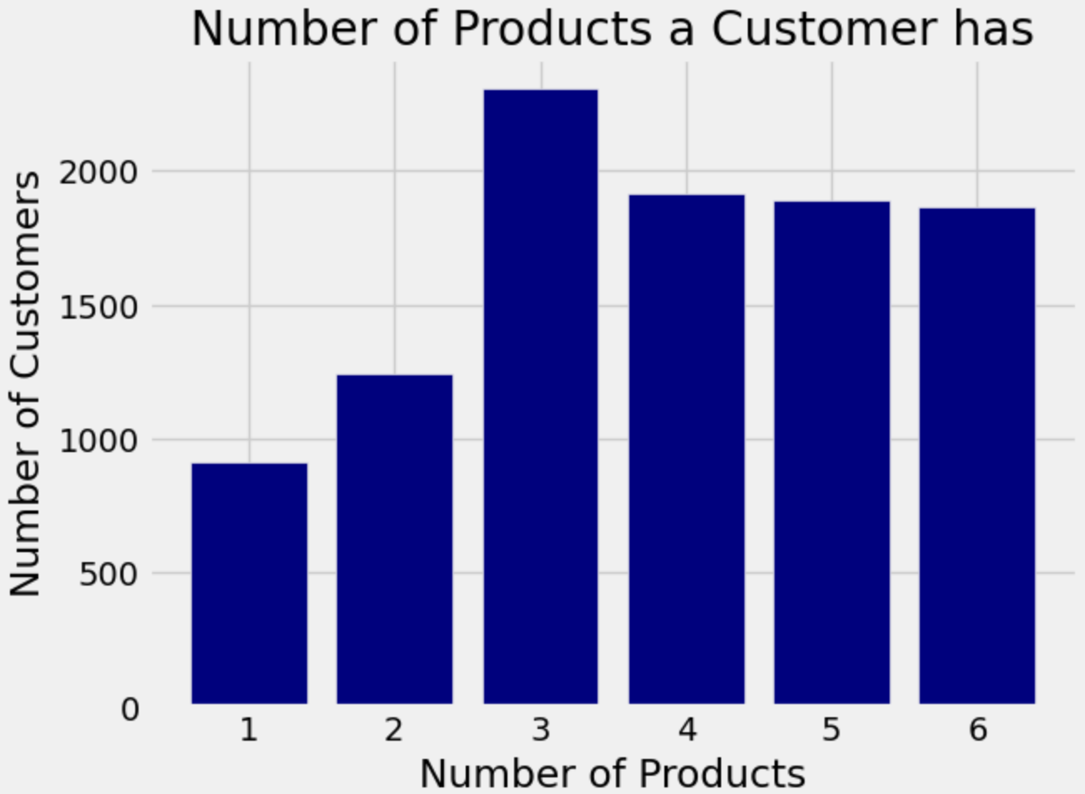
First, we’ll take a look at the number of products each customer holds in Figure 1 below.

Figure 1: A bar chart showing the number of products each customer holds from our dataset of 10127 customers.
From Figure 1 we can see that the number of products a customer holds skews larger with more of the sample holding 4-6 products. This is shown numerically with a mean of 3.81258, a median of 4, and 22.76% of customers holding 3 products in the data set. We can also see that the proportions of customers with 4,5, or 6 products are relatively similar while there is a sharp increase from 1 to 2 to 3.
Next, we’ll take a look at the income groups in Figure 2 below.
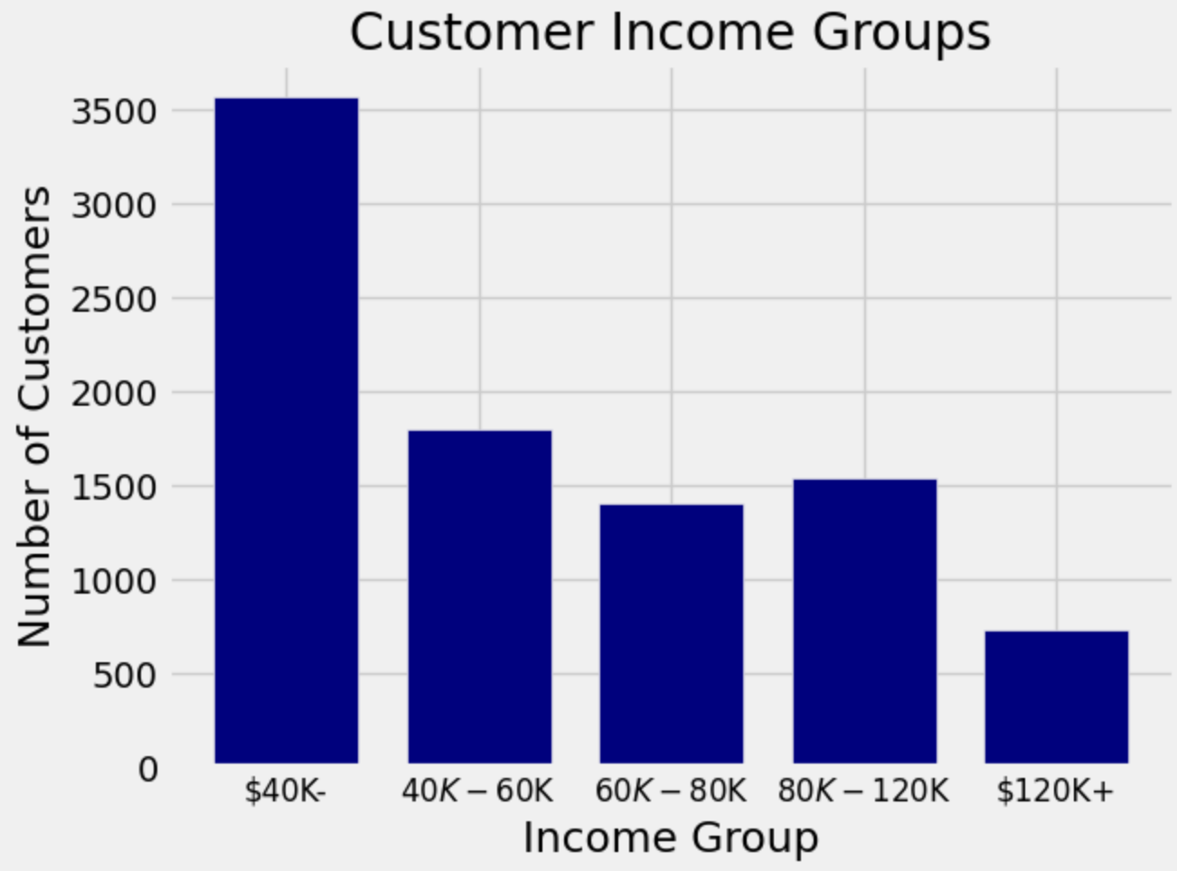
Figure 2: A bar chart showing the number of customers in each income group in the dataset of 10127 customers.

From Figure 2 we can see that most customers fall into the “Less than $40K” income group, making up 35.16% of the dataset. Due to the categorical nature of this variable, we are unable to determine the mean of the group.
After getting a sense of these two variables, we chose to group by income and calculate the mean number of products and mean churn proportion for those groups to see if there were any discrepancies to analyze. The churn proportion represents the proportion of customers who churned in the sample and it is calculated from churn status data.
Churn status is a qualitative boolean variable that indicates whether the customer has churned out of the bank’s credit card service. True for an attrited customer, False for an existing customer.
The grouped data is below in Table 1.

Income Category | Mean Product Count | Churn Proportion
Less than $40K | 3.77854 | 0.173315
$40K - $60K | 3.78324 | 0.151397
$60K - $80K | 3.83381 | 0.134807
$80K - $120K | 3.91694 | 0.157655
$120K + | 3.82336 | 0.171862

Table 1: A table of the customers grouped by income category along with each category’s respective mean number of products and churn proportion.

From Table 1 we can see that the $60K-80K income group has a noticeably lower churn proportion and the highest mean number of products. We will analyze the significance of these differences using simulations.

The Significance of Income:
After investigating both categories and how they relate to churn, it’s interesting to note that the income group with the lowest churn proportion, $60K-$80K, also had the highest average relationship count. This trend seemingly contradicts our original predictions for churn, making it a good candidate for hypothesis testing. The 0.134807 value for the churn proportion in the $60K-$80K income group seems low compared to the others and we’ll be running simulations to determine if that is due to random chance or if it could allude to greater trends.
From our data set as a whole, the proportion of churned customers to retained ones is 0.16065962 to 0.83934038. Since there are only two options, we’ll only be comparing the value for churned proportion. Income and total relationships may result in a lower churn rate but it is also possible that it is up to random chance. To determine which explanation is more likely from our data, we will run hypothesis testing based on the following hypotheses:
Null Hypothesis: Customers trend toward a churn proportion of 0.16065962, the lower churn rate of 0.134807 in the select income group is purely due to random chance.
Alternative Hypothesis: The customers in the select income group had a churn proportion of 0.134807 for reasons outside of random chance. Potential reasons could be their income level or the number of products they hold.
The results of the simulation are below.
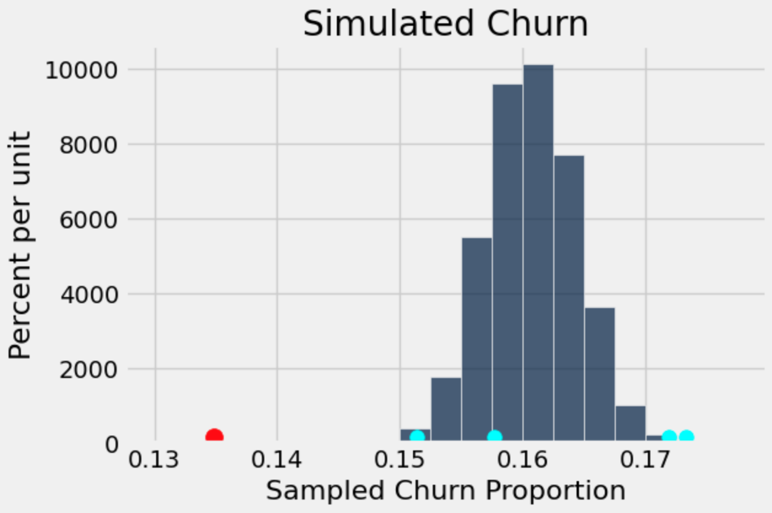

Figure 3: A histogram containing the results of simulation based on a churn proportion of 0.16065962 amongst 10127 customers. The red dot shows our observed value of a 0.134807 churn proportion amongst customers who make $60K-$80K. The blue dots show the churn proportions of the $40K-$60K, $80-$120K, $120K+, and Less than $40K from left to right.

From Figure 3, we can see that having a churn proportion of 0.134807 is out of the ordinary for a population that has an average proportion of 0.16065962. The p-value of this test can be visually discerned as 0, supporting our alternative hypothesis that the lower average proportion in the $60-80K income group is statistically significant and was not a product of random chance.
Figure 3 also shows the churn proportions of the other income groups plotted in cyan and we can see that these proportions are more in line with the simulated values and thus, the population churn average. It seems that the two points greater than 0.17 are also statistically significant which corresponds to the $120K+ income group holding the highest churn proportion and the $40K- income group holding the second highest churn proportion.

The Significance of Product Count:
We’ll use A/B testing to determine whether customer churn rates are statistically lower for those who hold more products with the bank. To use A/B testing, we need to split our data into two groups, in our case we want to isolate the impact of total products, so we’ll split the group into those who hold more products than average and those who hold fewer. The average number of products in the population is 3.8125802310654686 but due to each customer only having an integer value for total products, we chose to have the lower group consist of those with 1, 2, or 3 products with the bank and the upper group consist of those with 4, 5, or 6 products with the bank.
After noting that customers who held more products with the bank had lower churn rates we decided to use the difference between the upper and lower groups as a test statistic. The observed value for this statistic was -0.10529933007555038 showing that in our population, those with 4 or more products had lower churn rates than those with fewer products. To see if this is purely a coincidence, we will use A/B testing with the following hypotheses:
Null Hypothesis: Customer churn rates are the same across the population (0.16065962). Any differences in the sample are due to random chance.
Alternative Hypothesis: Customer churn rates are not the same in the population. Those with 4 or more products have lower average churn rates than those with fewer.
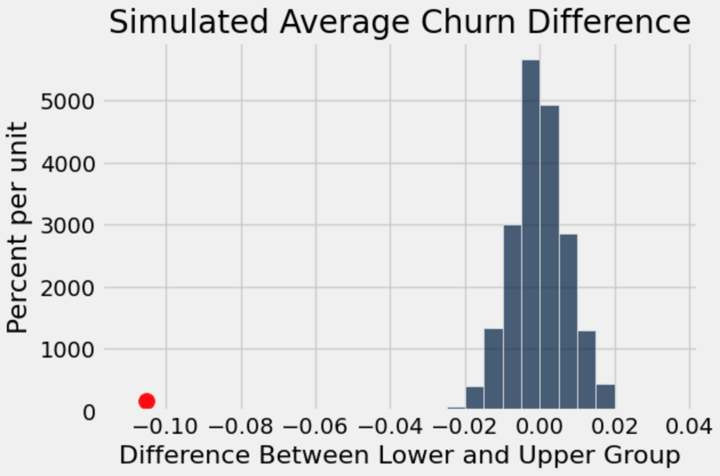
The results of the simulation are below:

Figure 4. A histogram containing the results of A/B testing based on the difference in average churn proportion between those who hold 4 or more products and those who hold fewer amongst 10127 customers. The red dot shows our observed difference of -0.10529933007555038.

From Figure 4 we can see that our observed difference of -0.10529933007555038 is also statistically significant and yields a clear p-value of 0, supporting the alternative hypothesis that customers with 4 or more products have on average lower churn rates than those with 3 or fewer. These results further confirm the theory that holding more products with a bank is an indicator of customer retention instead of churn.
Though this theory strays from my initial hypothesis, it does make sense. Banks will only issue more products to customers whom they trust as there is an increased risk with each new account or card (namely churn and default). Under this notion, those who hold 4 or more products with the bank have been deemed as trustworthy through, most likely, their credit score (a numerical measure of the creditworthiness of an individual), and as a result, have a lower average churn proportion.

Statistical Differences in the Spending Habits of Churned Customers:
After identifying the impact of customer characteristics, we’ll perform a similar analysis for each customer’s transaction details. However, since the proportion of customers who churned only makes up 16.07% of the customers in our dataset, we can use bootstrapping to identify trends on a larger scale. We’ll use bootstrapping to analyze the spending habits of customers who churned in comparison to those who didn’t and form confidence intervals for each simulation. The three variables we’ll examine are total transaction count, total transaction amount, and total revolving balance as we’d expect customers with the intent to churn to use their card less frequently, spend less on the card, and have less interest-gaining credit card debt.

Total Transaction Count and Amount:
Under the assumption that churned customers are only after the preliminary benefits credit card companies offer, we’d expect them to use their cards less than customers who don’t plan on churning since churners likely have another “main” credit card.
We’ll use simulations to see if there is a significant difference between churners and non-churners in their credit card transactions, both in amount and frequency. These two variables are defined as follows:
Total Transaction Count:
The total transaction count measures the total number of transactions on a customer’s credit card in the past 12 months. This quantitative variable is stored as an integer.

Total Transaction Amount:
The total transaction amount measures the total value of transactions on a customer’s credit card in the past 12 months. This quantitative variable is stored as an integer.

We’ll construct a confidence interval from 10,000 simulations for the mean difference between transaction amounts between a bootstrapped sample of customers who churned and those who didn’t. The results are shown below in Figure 5. We’ll construct a similar confidence interval for transaction frequency as well which is shown in Figure 6.
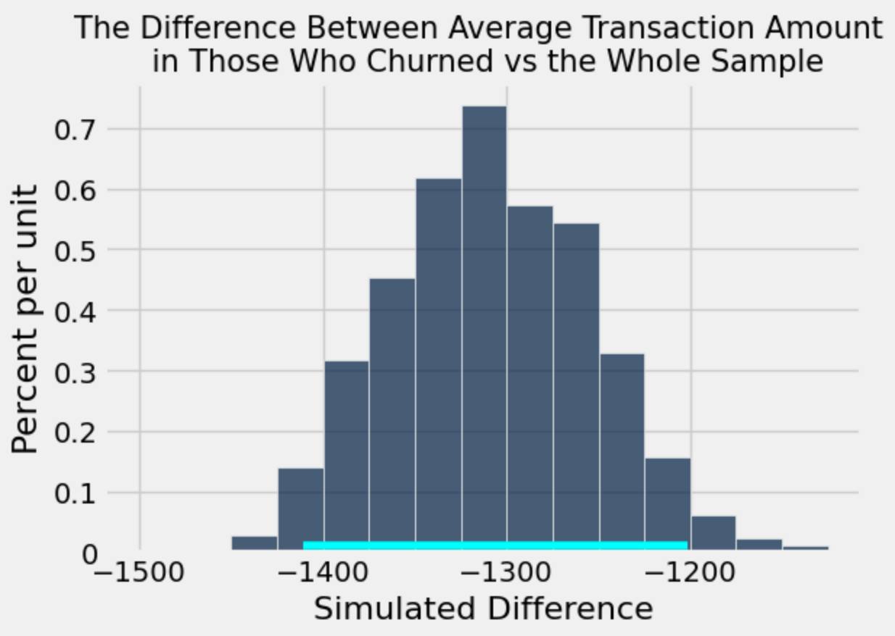
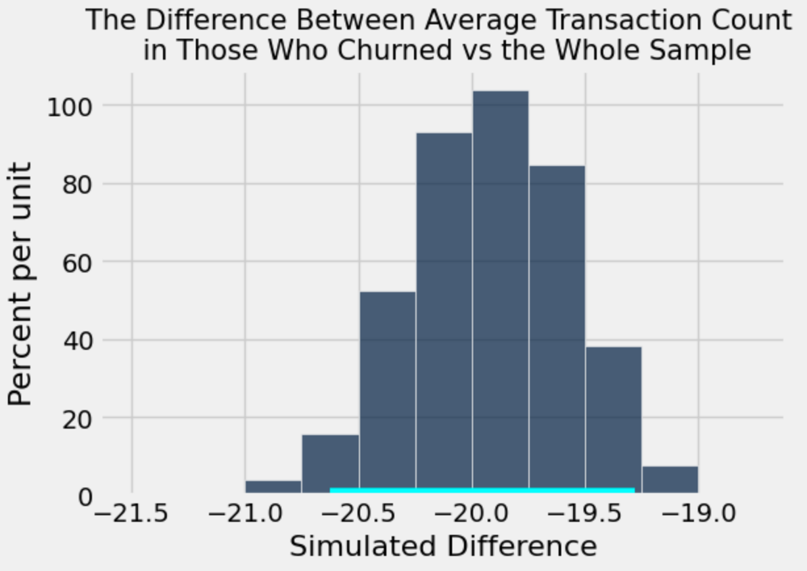
Figure 5. The results of 10,000 simulations of the difference in mean transaction count in churned customers versus non-churned customers generated using bootstrapping. | Figure 6. The results of 10,000 simulations of the difference in mean transaction amount in churned customers versus non-churned customers generated using bootstrapping.

From both Figures 5 and 6, we can clearly see that the results of all simulations yielded negative differences. By constructing a 95% confidence interval for each set of simulations, we get the interval (-20.62, -19.22) for the difference in transaction count and (-1416.62, -1197.10) for the difference in transaction amount. Since neither interval contains 0, we can conclude that customers who churned generally have a lower transaction frequency and amount when compared to customers who didn’t churn.

Average Revolving Balance:
Under the assumption that churned customers are aiming to cancel their card after redeeming preliminary benefits, we’d expect them to accumulate less credit card debt since churners wouldn’t want to garner any additional charges when they eventually cancel their card. Credit card debt can be measured using the average revolving balance variable which is defined as follows:
Average Revolving Balance:
The revolving balance is the portion of unpaid credit card spending at the end of a billing cycle and rolls over the next. Interest is typically charged on the revolving balance. This quantitative integer variable in our dataset is thus the sum of a customer’s revolving balance at the time of data collection with the interest rate on that balance factored in.

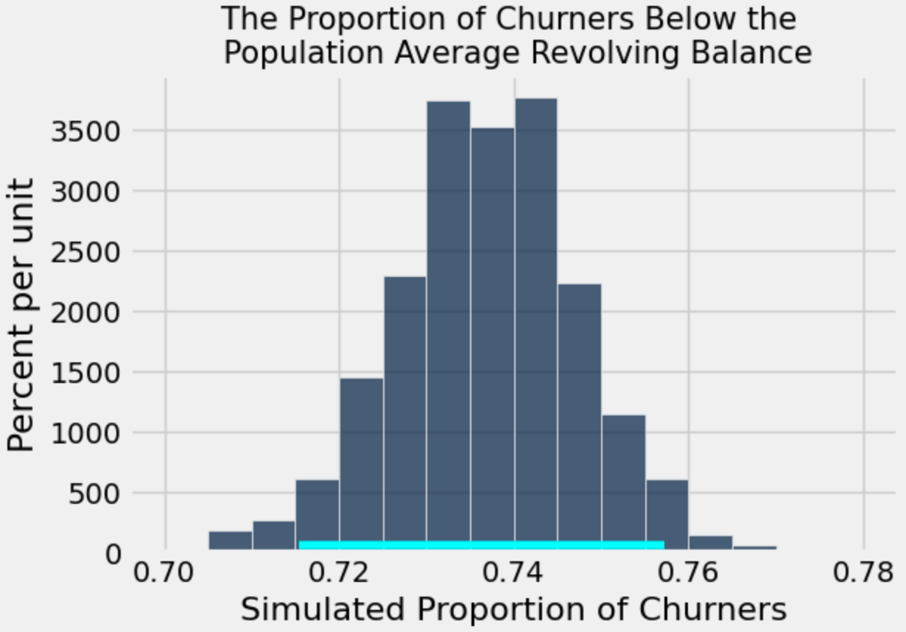
We’ll use simulations to estimate the proportion of churners who have an average revolving balance value that falls below the population average. We’ll construct a confidence interval from 10,000 simulations for the proportion of bootstrapped samples of churned customers who are below average for average revolving balance. The results are shown below in Figure 7.

Figure 7. The results of 10,000 simulations of the proportion of churned customers who lie below the population average for average revolving balance generated using bootstrapping.

From Figure 7, we can see that all plausible proportions are above 0.5. By constructing a 95% confidence interval for this simulation, we get the interval (0.725, 0.758). This confirms that a majority of churned customers have lower than average values for average revolving balance.

Creating a Model using Average Utilization Ratio and Credit Limit:
Under the assumption that trends in customer credit card spending patterns can indicate churn status, we’ll compare the average utilization ratio and credit limit and model the relationship between the two variables which are defined as follows:
Average Utilization Ratio:
The utilization ratio is the percentage of credit used of the total available credit in one billing period. It is calculated by dividing the sum of credit spent and money withdrawn by the sum of the limit for credit card spending and money withdrawal. Therefore, the average utilization ratio variable is a quantitative measure of the average utilization ratio for each billing period over the past 12 months stored as an integer.

Credit Limit:
This quantitative variable tracks the customer’s credit limit, the maximum amount of money a lender will allow you to spend on a credit card stored as an integer.

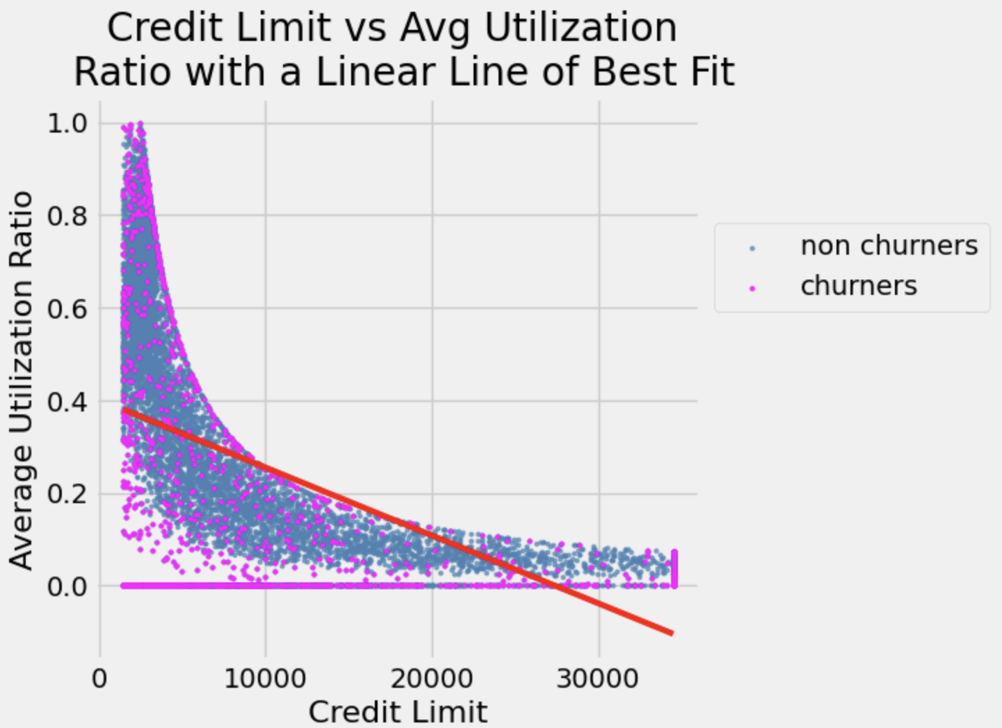
These two variables were selected as they both link to the average revolving balance variable that we earlier determined was significant. Those with high revolving balance values have high utilization ratios and likely have low credit limits that facilitate the accumulation of debt. These values are graphed below in Figure 8 with credit limit on the x-axis and the average utilization ratio on the y-axis along with a linear line of best fit and colors indicating the customer’s churn status.

Figure 8. The graph of credit limit and average utilization ratio for the 10127 customers in our data set with a line of best fit plotted. Each point is also color-coded to indicate the customer’s churn status, with pink representing those who churned and blue representing those who did not.

Although Figure 8 shows a clear logarithmic relationship between the two variables, there is still a linear correlation. The linear relationship is moderately weak with an r-value of -0.48 and a slope of -1.46498649115e-05, where it’s important to keep in mind the vastly different scales of the two axes. These results show that the two variables are negatively correlated, meaning as credit limit increases, the average utilization ratio decreases as well. This trend makes sense because as you become able to spend more on your card, it becomes increasingly unlikely that you’ll consistently spend all of it, yielding a lower utilization ratio.
We can also notice a churn region from Figure 8, where there is a logarithmic group of pink “churner” data points that lie below the logarithmic grouping of blue “non-churner” data points. This visual trend suggests that an especially low average utilization ratio combined with a similarly low credit limit can indicate churn in a customer.
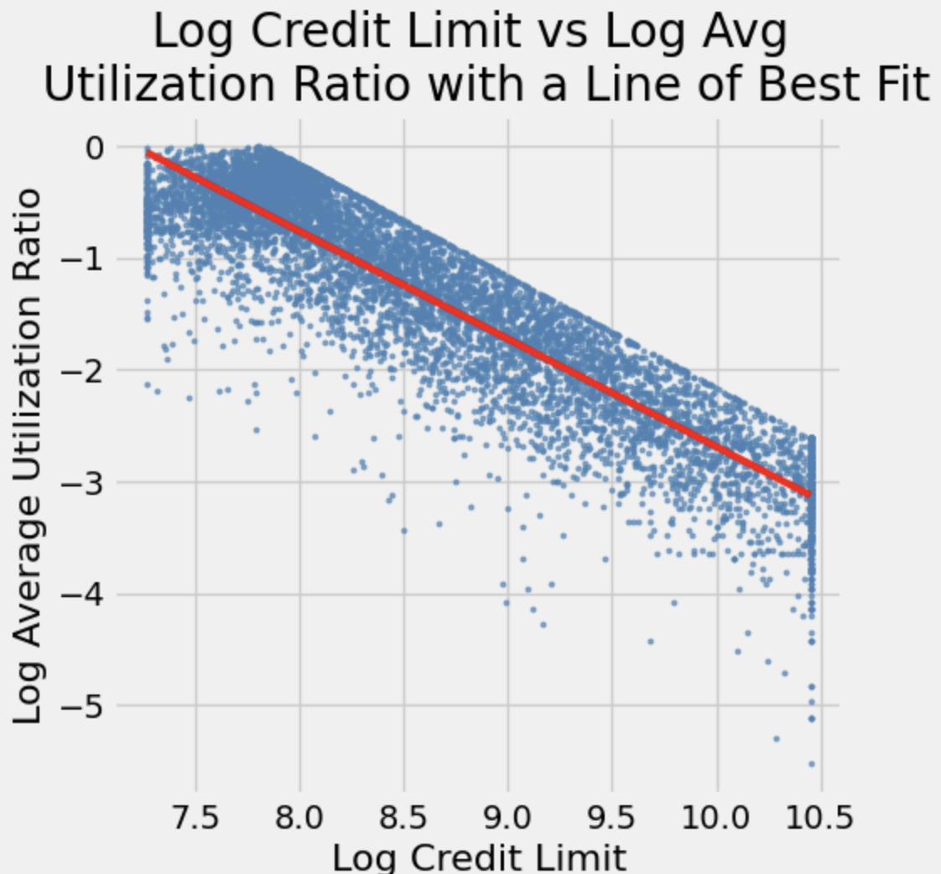
Since we noticed such a strong logarithmic relationship between our two variables, let’s model them in a log-log scale to linearize our data and see if we can find a more accurate line of best fit. The results of the linearization are shown below in Figure 9.

Figure 9. The graph of the log credit limit and the log average utilization ratio for the 10127 customers in our data set with a line of best fit plotted.

The line of best fit from Figure 9 definitely seems like a better fit which is confirmed by the calculated r-value of -0.90. The slope on the log-log linearization is -0.96. Now that we have the log-log values for the line of best fit, we can convert them back into our original linear scale and obtain a logarithmic line of best fit as shown below in Figure 10.

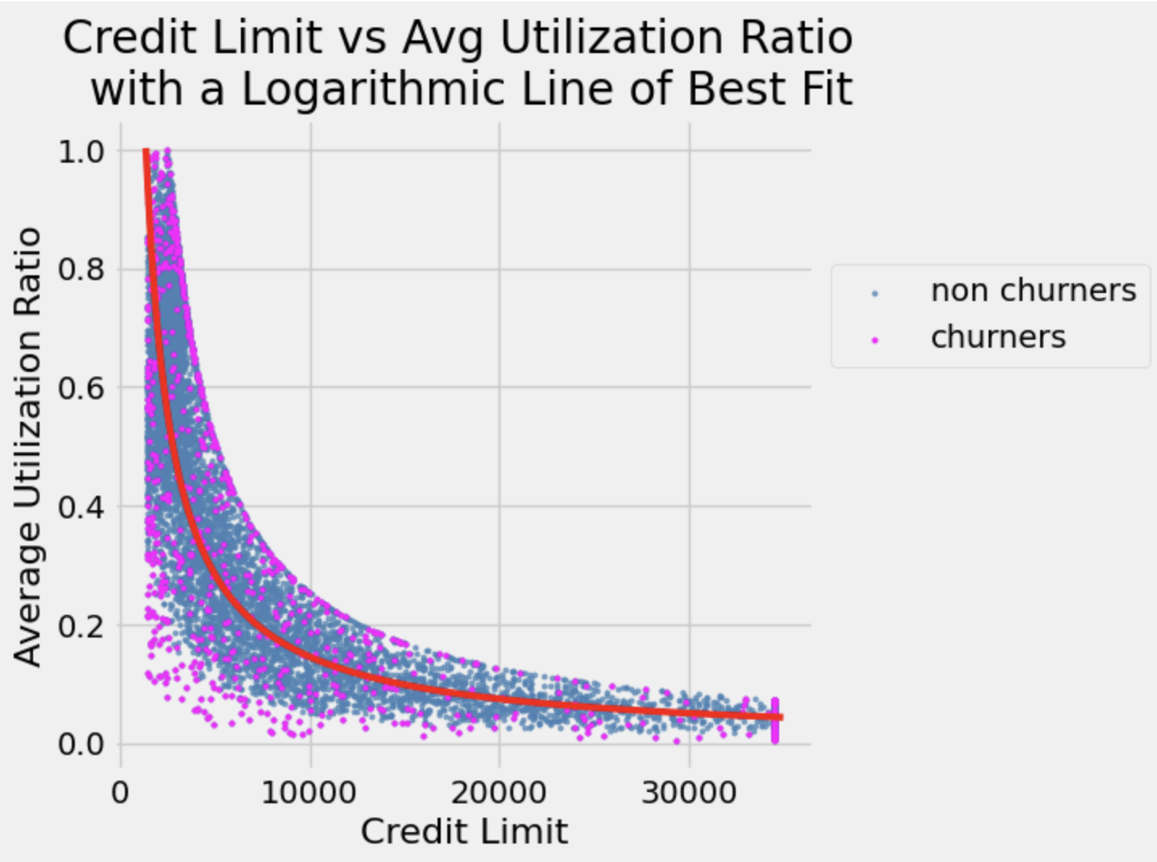

Figure 10. The graph of credit limit and average utilization ratio for the 10127 customers in our data set with a logarithmic line of best fit plotted. Each point is also color-coded to indicate the customer’s churn status, with pink representing those who churned and blue representing those who did not.

Now that we have constructed two regression models for our two variables, we can compare the two to see how much of an improvement the log-log linearization by calculating the root mean squared error (RMSE) of each model.
The linear model has an RMSE value of 0.2414, which once again is determined by the scale of our variables, so it’s best to compare the values only within the context of our data.
The log-log model has an RMSE value of 0.1614, a notable decrease compared to the linear model. However, in order to successfully map our data to the log-log scale, we had to exclude the zeros from both the average utilization ratio and credit limit data. Since we did not initially remove the zeros for our linear model, we need to construct a third model – linear without zeros – to correctly analyze the improved accuracy from the log-log model.
The linear nonzero model has an RMSE value of 0.1871, lying between the two previous values. This new RMSE is actually closer to our log-log RMSE than the linear RMSE which makes sense considering the composition of our original data. If we look at Figure 8, we see a lot of data points with an average utilization ratio of 0. These values skew the line of best fit to have a steeper slope and explain why our RMSE improved when we removed the zeros from the linear model, as the line of best fit could more accurately represent the general pattern of data. Our process of removing zeros can be likened to that of removing outliers which understandably improves the accuracy of our model.

Prediction using Logistic Regression:
In a brief attempt to use machine learning to classify our data, we utilized Scikit-Learn’s open-source machine-learning library to train a logistic regression model for our dataset. Logistic regression is a supervised machine-learning algorithm that estimates the probability of an event occurring (binary classification) by computing the log odds (probability of the event occurring divided by the probability of the event not occurring). In our case, the event is whether the customer churned or not.
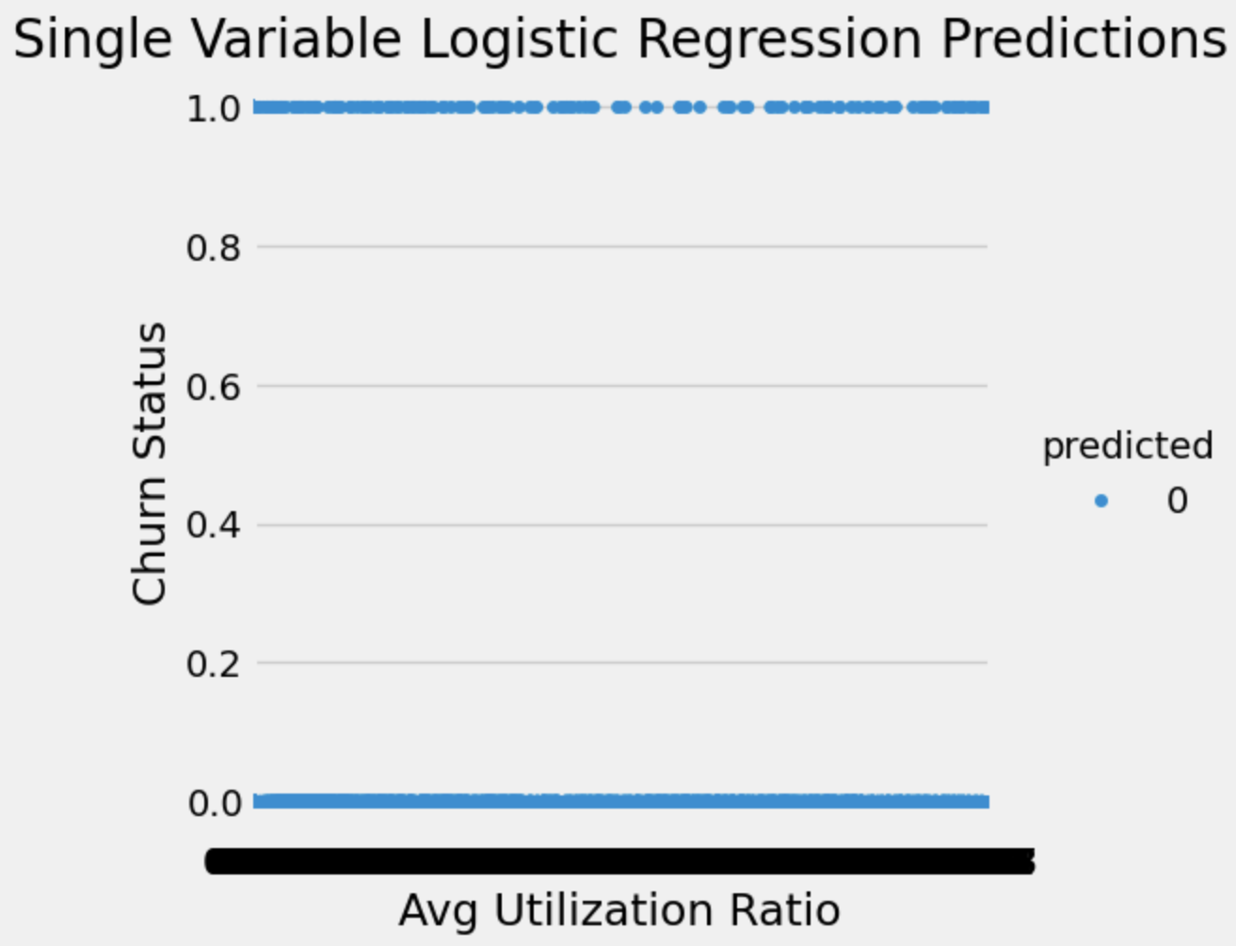
We first trained a single variable logistic regression model where we used the average utilization ratio as the sole factor in classification. The results of the single variable logistic model on the testing set of data are shown below in Figure 11.

Figure 11. A graph showing all 10127 customers in our data and their average utilization ratio compared to their churn status along with our model’s prediction of their churn status.

From Figure 11, we can see that our single variable model predicted that none of our customers churned, as shown by a single color throughout the graph and the singular label in the key. Scikit-learn has an accuracy score function that computes how well the predictions match the true values. The single variable model obtained an accuracy score of 0.8366, serving as a baseline for more complicated logistic models as it failed to predict any of the churning customers. This could be due to the lack of clear separation between the average utilization ratio of those who churned and those who didn’t.
To see if the factors we determined as significant earlier could be utilized for classification, we added the credit limit, total revolving balance, total transaction amount, and total transaction count to our logistic model (adding the number of products caused the logistic model to overload and was thus excluded). This multivariable logistic regression model understandably cannot be graphed but we can compute its accuracy score and compare it to the baseline which predicted none of the churners correctly. Our multivariable model has an accuracy score of 0.8662 which isn’t a huge improvement on baseline but shows that it did correctly classify some of the churned customers.
In conclusion, it seems that a logistic regression model is capable of predicting the churn status of customers from our dataset though it doesn’t seem to be the most accurate or successful model. As we saw in Figure 8, this is likely due to the large overlap of churned and remaining customers in almost all of the variables, making it difficult for the model to identify clear categories and make predictions. The original dataset did come with two columns labeled “Naive_Bayes_Classifier…,” another machine learning algorithm, suggesting that someone had previously used a Naive Bayes Classifier on the data set. Since Naive Bayes generates classification instead of being given the features beforehand like in Logistic Regression, it is likely to be more successful in datasets like ours that contain many variables that contribute in varying degrees and would be difficult to sum up with the Logistic Regression approach.

Conclusion:
After closely analyzing several of the dataset’s variables, we can conclude that a multitude of variables play a role in determining customer churn. Below are the specific impacts of each variable we analyzed on the likelihood of customer churn.
- Income Category, through hypothesis testing, we discovered that those in the $60-80K income group, the median income group, had a lower churn proportion compared to other income groups. We also found that the $120K+ and $40K- income groups, the highest and lowest groups respectively, are associated with a higher churn proportion.
- Total Product Count, through A/B testing, we found that customers with 4 or more products have, on average, lower churn rates than those with 3 or fewer. From these results, we know that holding fewer products with a bank is an indicator of customer churn.
- Total Transaction Count, we formed the 95% confidence interval (-20.62, -19.22) for the average difference of transaction count between churned customers and retained customers, and since the interval doesn’t include 0, we know that customers who churned have a lower transaction frequency than customers who didn’t churn.
- Total Transaction Amount, we formed the 95% confidence interval (-1416.62, -1197.10) for the average difference of transaction amount between churned customers and retained customers, and since the interval doesn’t include 0, we know that customers who churned have a lower transaction amount than customers who didn’t churn.
- Average Revolving Balance, we formed the 95% confidence interval (0.725, 0.758) for the proportion of churned customers who had below average values for average revolving balance. Since the interval is greater than 0.5, we know that most customers who churned have lower average revolving balance values than customers who didn’t churn.
- Average Utilization Ratio and Credit Limit, after modeling the two variables, we identified a “churn region” that lay below the logarithmic grouping of non-churning customers. We can thus say that an especially low average utilization ratio combined with a similarly low credit limit can indicate churn in a customer. Furthermore, now that we have a model, we can plot where future customers will be and predict churn if they fall into the “churn region.”

Citations:
Credit Card customers. (2020, November 19). Kaggle. https://www.kaggle.com/datasets/sakshigoyal7/credit-card-customers/data
MoneyGeek Team. (2024, March 21). Credit card glossary: Basic terms to know. MoneyGeek.com. https://www.moneygeek.com/credit-cards/resources/credit-card-glossary/

